Classification of Different Types of Testing

Testing is divided into two types – Functional Testing and Non functional Testing

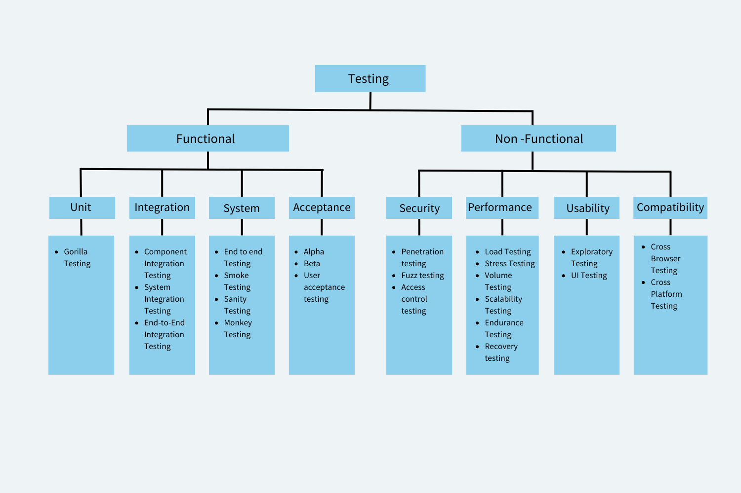

Functional Testing
focuses on verifying the functionality of the software system. It is a type of testing that is done to ensure that the system works as intended and meets the functional requirements specified by the stakeholders. Functional testing is concerned with what the software system does, and how it performs its functions. Some examples of functional testing include unit testing, integration testing, and acceptance testing.

Example of Functional Testing:
Let’s say you’re testing a login page of a website. The functional requirements of this login page may include:
- The user should be able to enter their username and password.
- The system should authenticate the user’s credentials and grant access if the credentials are correct.
- The system should deny access if the user’s credentials are incorrect.
To test the functionality of this login page, you may perform the following functional tests:
- Enter valid username and password and verify that the user is able to successfully login.
- Enter invalid username and password and verify that the user is not able to login and an appropriate error message is displayed.
- Verify that the login page displays correctly on different browsers and devices.
- Verify that the password field is secure and does not display the entered password.
- Verify that the “Forgot Password” feature works correctly and allows users to reset their passwords.

Non Functional Testing
focuses on evaluating the non-functional aspects of the software system. This type of testing includes testing for performance, usability, reliability, scalability, and security. Non-functional testing is concerned with how well the software system performs its functions, rather than what it does. Some examples of non-functional testing include load testing, stress testing, usability testing, and security testing.
Example of Non functional Testing:
Let’s say you’re testing the performance of a website. The non-functional requirements of this website may include:
- The website should be able to handle a certain number of concurrent users.
- The website should load pages within a certain amount of time.
- The website should be responsive and display correctly on different devices and screen sizes.
- Accessible for users who are differently abled.
- The website should be secure and protect user data.

What are the Software Testing Techniques and How are They Different from Testing Types?
Software test techniques refer to the methods used to test a software system. The most common software test techniques are black, white, and grey box testing. These techniques are used to test a software system at different levels of detail, from a high-level view of the system’s functionality to a detailed view of its internal workings. Here’s a brief overview of each of these test techniques:
- Black box testing: It is a type of software testing technique that focuses on testing the functionality of a software system without any knowledge of its internal workings. This technique is used to test the system from a user’s perspective, focusing on testing whether the system works as expected and meets the user’s needs. The tester only knows the inputs and expected outputs of the system and does not know how the system works internally.

- White box testing: It is a software testing technique that focuses on testing the internal workings of a software system. This technique is used to test the system from a developer’s perspective, focusing on testing the system’s internal logic, performance, and efficiency. The tester has complete knowledge of the system’s internal details, including the code and its implementation.

- Grey box testing: Grey box testing is a software test technique that combines the approaches of both black box and white box testing. This technique is used to test the system from a developer’s perspective, where the focus is on testing some of the system’s internal workings but not all. The tester has partial knowledge of the system’s internal details, and this technique is often used in system integration testing.
On the other hand, testing types refer to the different types of testing that can be performed within these test techniques. For example, functional testing, regression testing, performance testing, security testing, usability testing, etc., are all different types of testing that can be performed within the black box, white box, or grey box test techniques. Testing types are used to test different aspects of the software system and to ensure that it meets the stakeholders’ requirements.

Types of Functional Testing
1. Unit Testing
Unit testing is a software testing type in which individual units/components are tested in isolation from the rest of the system to ensure that they work as intended. A unit refers to the smallest testable part of a software application that performs a specific function or behavior. A unit can be a method, a function, a class, or even a module. They can be run in isolation or in groups. Unit tests are typically written by developers to check the correctness of their code and ensure that it meets the requirements and specifications.
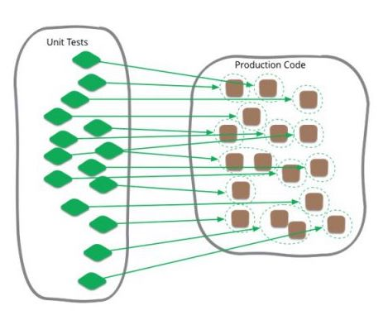
Example of Unit Testing:
A developer has scripted a password input text field with its validation ar (8 characters long, must contain special characters.); makes a unit test to test out this one specific text field (has a test that only inputs 7 characters, no special characters, empty field)

Advantages of Unit Testing
- Early detection of Bugs
- Simplifies Debugging Process
- Encourages Code Reusability
- Improves Code Quality
- Enables Continuous Integration

2. Integration Testing
Integration testing is a testing type in which different modules or components of a software application are tested together as a group to ensure that they work as intended and are integrated correctly. The main aim of integration tests is to identify issues that might come up when multiple components work together. It ensures that individual code units/ pieces can work as a whole cohesively.
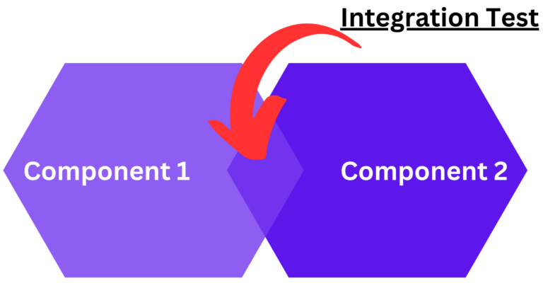

Types of Integration testing

Revealing defects takes center stage in integration testing, emphasizing the interaction time between integrated units. As for integration test methods, there exist four types, which are as follows:

1.Big Bang Integration Testing:

In this approach, all or most of the developed modules are integrated simultaneously, and then tested as a whole. This method is straightforward but can be challenging if there are many modules, as identifying the exact source of a defect can be difficult.

Example: Imagine a simple application comprising three modules: User Interface (UI), Database (DB), and Processing Logic (PL). In Big Bang Integration Testing, all these modules are integrated at once and tested together.

1.1. Advantages of Big Bang Integration Testing:

- Straightforward Approach: Integrates all modules at once, making the process easy to understand and implement in smaller projects.

- Holistic Testing Environment: Provides a complete picture of the system's functionality when all modules are combined.

1.2. Disadvantages of Big Bang Integration Testing:

- Challenging Defect Localization: With all modules tested simultaneously, pinpointing the exact source of an issue can be difficult.

- Risk of Late Discovery: Defects may only become apparent late in the development cycle, leading to potential delays and increased costs.

- Limited Scalability: Not well-suited for large-scale projects with numerous modules due to its complexity.

2. Incremental Integration Testing:

This method involves integrating modules one by one and testing each integration step. It helps in isolating defects related to interfacing.

2.1. Advantages of Incremental Integration Testing:
- Focused Defect Identification: Easier to locate and fix defects since modules are integrated and tested one at a time.

- Early Problem Detection: Facilitates the early discovery of issues, allowing for more efficient resolution.

- Flexibility in Integration: Can be adapted to different project requirements and structures.

2.2. Disadvantages of Incremental Integration Testing:
- Incremental Complexity: Requires careful planning and execution to ensure proper integration sequence.

- Potential Integration Overhead: The process can be time-consuming, especially in cases where numerous modules must be integrated sequentially.

Incremental Integration Testing can be further divided into:

- Top-Down Integration Testing: Starts from the top-level modules and progresses downwards, integrating and testing one module at a time. Stubs (dummy modules) are often used to simulate lower-level modules not yet integrated.

Example: In a layered application, the top layer (e.g., User Interface) is tested first with stubs replacing the lower layers. Gradually, real modules replace the stubs.

- Bottom-Up Integration Testing: Begins with the integration of the lowest-level modules and moves upwards. Here, drivers (temporary modules) are used to simulate higher-level modules not yet integrated.

Example: In the same layered application, integration might start with the database layer, using drivers to simulate the upper layers.

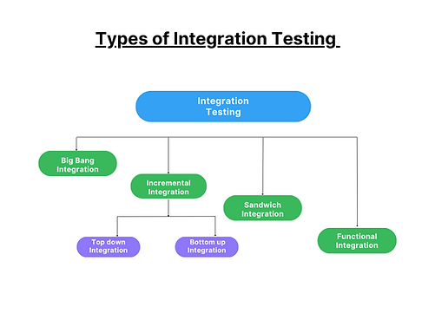

3. Sandwich (Hybrid) Integration Testing:

Combines both top-down and bottom-up approaches. It is useful in large projects where different teams work on various segments of the application.

Example: While one team works on the top layers using a top-down approach, another could work on the lower layers using a bottom-up approach. Eventually, the two are merged.

3.1. Advantages of Sandwich (Hybrid) Integration Testing:
- Versatility: Combines the strengths of both top-down and bottom-up approaches, making it suitable for various project sizes.

- Parallel Development: Allows different teams to work simultaneously on different parts of the project.

3.2. Disadvantages of Sandwich (Hybrid) Integration Testing:
- Coordination Challenges: Requires significant coordination between teams working on different parts of the project.

- Complex Management: The dual approach can lead to complexity in managing the integration process.

4. Functional Incremental Integration Testing:

In this method, the integration is based on the functionality or functionality groups, rather than the structure of the software.

Example: If a software has functionalities A, B, and C, functional incremental integration might first integrate and test A with B, then add C.

4.1. Advantages of Functional Incremental Integration Testing:
- Functionality Focused: Prioritizes the integration of modules based on functionality, which can be more intuitive for certain projects.

- Flexible Testing Scope: Allows for testing of specific functional areas, making it efficient for identifying function-related defects.

4.2. Disadvantages of Functional Incremental Integration Testing:
- May Overlook Structural Issues: While focusing on functionality, it might miss structural or integration defects between non-functional components.

- Requires Clear Functional Separation: Effective implementation demands well-defined functional boundaries within the software.

3. System Testing
System testing is a testing type that tests the entire software application as a whole and ensures that the software meets its functional and non-functional requirements. System testing is typically performed after integration testing. During system testing, testers evaluate the software application’s behavior in various scenarios and under different conditions, including normal and abnormal usage, to ensure that it can handle different situations effectively.
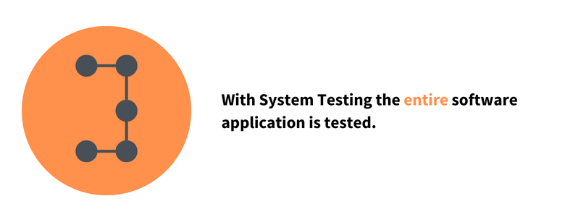
Example of System Testing
A software application consists of a web-based front-end, a middleware layer that processes data, and a back-end database that stores data. The system test for this scenario would involve the following steps:
- The user accesses the front-end interface and submits an order, including item details and shipping information.
- The middleware layer receives the order and processes it, including verifying that the order is valid and the inventory is available.
- The middleware layer sends the order information to the back-end database, which stores the information and sends a confirmation message back to the middleware layer.
- The middleware layer receives the confirmation message and sends a response back to the front-end indicating that the order has been successfully processed.
Advantages of System Testing
- Identifies and resolves defects or issues that may have been missed during earlier stages of testing.
- Evaluates the software application’s overall quality, including its reliability, maintainability, and scalability.
- Increases user satisfaction
- Reduces risk
Types of System Testing
a. End to End Testing
is a testing methodology that tests the entire software system from start to finish, simulating a real-world user scenario. The goal of end-to-end testing is to ensure that all the components work together seamlessly and meet the desired business requirements. Most often people use the term system testing and end to end testing interchangeably. However both of them are different types of testing.
System testing is a type of testing that verifies the entire system or software application is working correctly as a whole. This type of testing includes testing all the modules, components, and integrations of the software system to ensure that they are working together correctly. The focus of system testing is to check the system’s behavior as a whole and verify that it meets the business requirements.
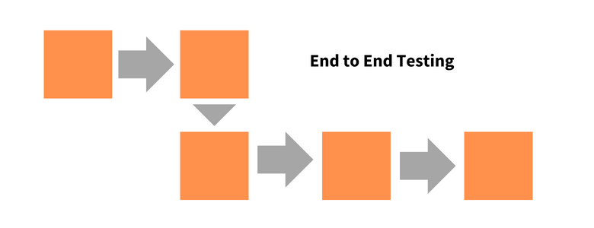
End-to-end testing, on the other hand, is a type of testing that verifies the entire software application from start to finish, including all the systems, components, and integrations involved in the application’s workflow. The focus of E2E testing is on the business processes and user scenarios to ensure that they are working correctly and meet the user requirements.
Example of End to End Testing
E-commerce transaction: End-to-end testing of an e-commerce website involves testing the entire user journey, from product selection to payment, shipping, and order confirmation.
Advantages of End to End testing
- Allows you to test real world scenarios
- Comprehensive testing
- Improves quality
b. Monkey Testing
is a testing type where the tester tests in a random manner with random inputs to analyze if the application breaks. The objective of monkey testing is to verify if an application crashes by giving random input values. There are no special test cases written for monkey testing.

Example of Monkey Testing
A tester randomly turning off the power or unplugs the system to test the application’s ability to recover from sudden power failures.
Advantages of Monkey Testing
- Does not require extensive knowledge
- Ensures reliability
- Used to identify bugs that cannot be discovered through traditional methods
- Cost Effective
Difference between Monkey Testing and Gorilla Testing: Monkey testing and gorilla testing are not the same, although they both involve sending random input data to the software system to observe its behavior. Monkey testing is focused on finding defects related to unexpected or invalid input, while gorilla testing is focused on thoroughly testing a specific feature or functionality of the software system.
c. Smoke Testing
is a testing type that is conducted to ensure that the basic and essential functionalities of an application or system are working as expected before moving on to more in-depth testing.
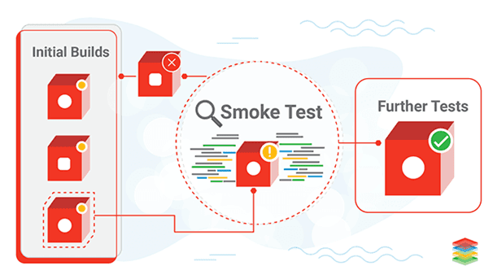
Source
Also Read: Sanity Testing vs Smoke Testing
Example of Smoke Testing
Smoke testing for login will check whether the login screen is accessible and if the users can log in.
Advantages of Smoke Testing
- Quick Feedback
- Early detection of defects
4. Acceptance Testing
Acceptance Testing verifies whether a software application meets the specified acceptance criteria and is ready for deployment. It is usually performed by end-users or stakeholders to ensure that the software meets their requirements and is fit for purpose.
Acceptance Testing can be further divided into two types: User Acceptance Testing (UAT) and Business Acceptance Testing (BAT). User Acceptance Testing is performed by end-users to validate that the software meets their needs and is easy to use. Business Acceptance Testing is performed by stakeholders to ensure the alignment of business/functional requirements with the organization’s objectives.
Example of Acceptance Testing
Conducting tests to meet if an app meets the requirements of the user. For a banking app, acceptance testing would involve testing the app for login, account management, fund transfer, statement download, card payment etc.
Advantages of Acceptance Testing
- Increased stakeholder engagement
- Reduced Risk
- Reduced costs
Types of Acceptance Testing
a. Alpha Testing
Alpha testing is a type of testing that is performed in-house by the development team or a small group of users. It is the first phase of testing that is conducted before the software is released to the public or external users. Alpha testing is a crucial step in the software development process as it helps to identify bugs, defects, and usability issues before the product is released.
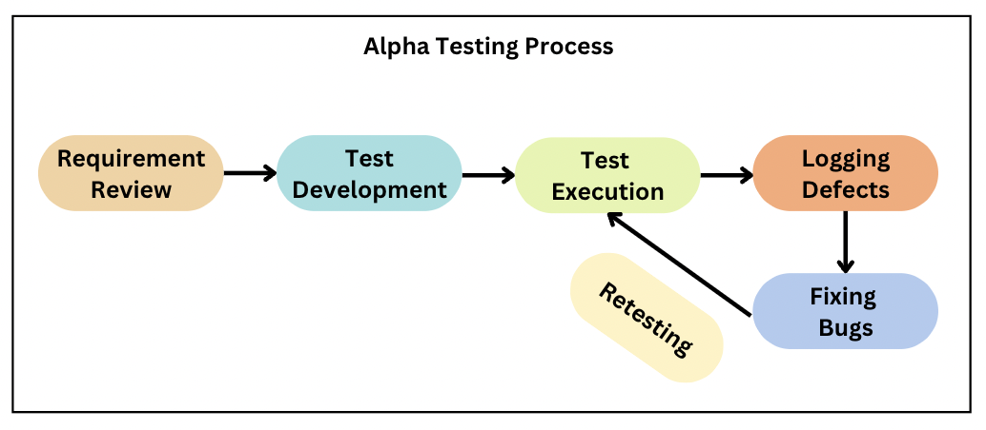
Example of Alpha Testing
A game development company is creating a new game. The development team performs alpha testing by testing the game’s performance, such as loading times, graphics, sound effects, and gameplay.
Advantages of Alpha Testing
- Early detection of issues
- Enhanced user experience
- Feedback from internal users
b. Beta Testing
Beta testing is a type of testing that is performed by a group of external users who are not a part of the development team. The purpose of beta testing is to gather feedback from real users and to identify any issues that were not found during the alpha testing phase.
Example of Beta Testing
A software company is releasing a new feature of its product. The company invites a group of external users to beta test the product and provide feedback on any bugs, defects, or issues that were not found during the alpha testing phase.
Advantages of Beta Testing
- Real-world feedback
- Marketing and promotion
- Enhanced user experience
c. User acceptance testing
User acceptance testing is a type of acceptance testing that is performed by the end-users of the software system. The focus of UAT is to validate the software system from a user’s perspective and to ensure that it meets their needs and requirements. UAT is typically performed at the end of the software development lifecycle.
Example of User Acceptance Testing
A company asks a batch of its customers to test the website and provide feedback on its functionality, usability, and overall user experience. Based on the feedback, it makes the necessary changes and improvements to the website.
Advantages of user Acceptance Testing
- Reduced development costs
- Improved customer satisfaction

